20 February 2024

ACCEPTANCE LETTER

Client: CITY OF EKURHULENI

RE: Contract No: AS 08-2023

Attention: Shandre’ Daniels

On behalf of Sithembe Transportation Projects, I hereby accept the appointment letter dated 15 February 2024, for the tender: THE APPOINTMENT OF SERVICE PROVIDERS FOR THE SUPPLY, DELIVERY AND OFF-LOADING OF ELECTRICAL ITEMS (ACCESSORIES) ON AN AS AND WHEN REQUIRED BASIS FROM DATE OF AWARD UNTIL 30 JUNE 2026.

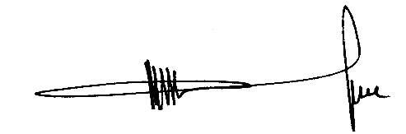
……………………………………………
MR. M.V LUKHELE
Director

